Homecare treatment for gum disease
- day ONe
You may drink water as you feel ready but try to avoid eating anything for 2 hours after surgery- as the numbness wears off and once you feel comfortable to eat, be careful not to bite your cheek or tongue
Restrict your diet to soft foods for the next 24 hours. Foods such as yogurt, scrambled eggs, and soup until you can comfortably chew. Chew on the side of your mouth opposite of the treatment area.
Avoid alcoholic drinks and hot or spicy foods until your gums are healed.
Do not use tobacco products for at least 72 hours because tobacco slows healing.
Brush treated area very lightly for the first night. To make this more comfortable, first rinse your toothbrush under hot after to soften the bristles.
- Days 2-5
After 24 hours- reduce discomfort and swelling by gently rinsing your mouth with warm salt water 3 times a day. Use1 tsp of salt to a glass of warm water.
Begin flossing lightly, and gradually return to your usual home care over the next week. It is normal to have some slight bleeding for the first few day when your brush and floss the treated area
Use a desensitizing toothpaste if your teeth are sensitive to hot, cold, or pressure. If we prescribed a medicated mouth rinse, use it as directed.
Call us if discomfort is not diminishing day by day, or if swelling increases or continues beyond 3 or 4 days. Please call us if you have any questions or concerns.
- long Term
Starting one week after periodontal treatment, it is recommended to rinse with 1 tsp of baking soda to a glass of warm water once a day to help neutralize acids and promote continuous tissue healing and health.
Use a waterpik oral irrigator or water flosser with 6 drops of Bleach added to a full water reservoir (like swimming pool water). ONLY do this twice a week to help control the harmful bacteria that cause periodontal disease
DO NOT use Bleach in the waterpik reservoir more than twice a week!

Keep your regularly scheduled professional cleaning appointment

MOST IMPORTANTLY
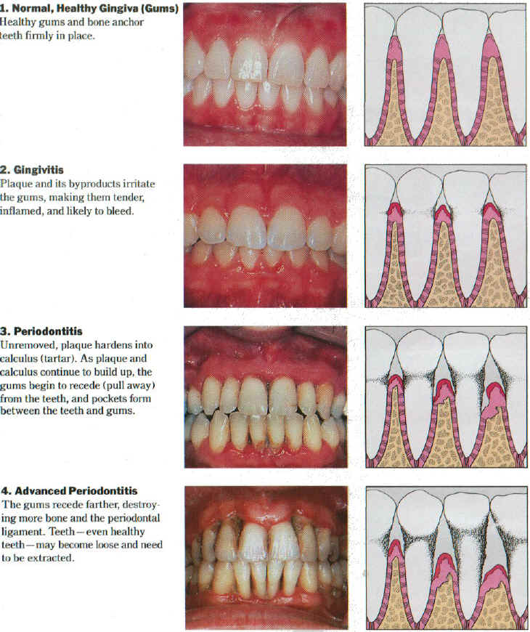
Visit your dental team for periodontal maintenance every 3-4 months!

